KHS Yearbook: Requirements for Senior Photos
All Senior Pictures & the Info Sheet are due by Christmas break of your senior year!

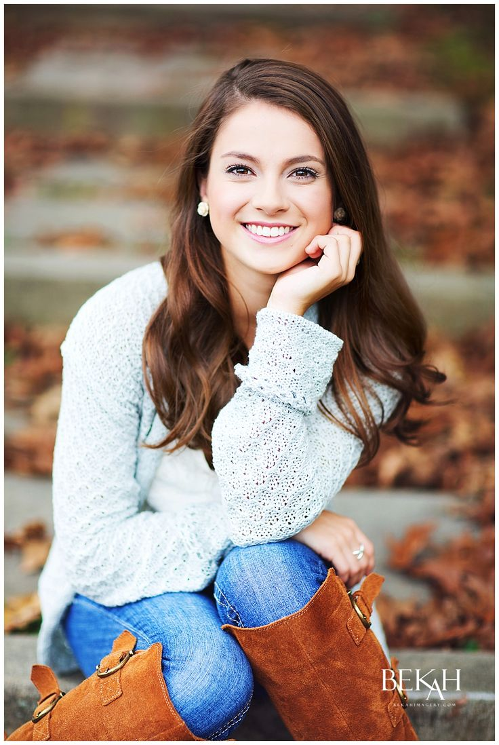
1. Senior Portrait
- Senior is seated/clear view of face. Your face should take up at least 1/4 the height of the picture.
- Clothing should follow school dress code (no hats if they block your face, clothing with school appropriate slogans etc).
- No text printed over the photo (ex. “Class of 2013”)
- No special effects: Crisp focus, no blurred filters. Or cropped/blurred edges/borders.
- Vertical Orientation (you may submit an horizontal image for the slide show).
- Color

Note: photos that don’t fit the yearbook requirements may be used in the senior slide show at graduation. These may also be turned in to Ms. Burcroff. Please specify if they are to be used in the yearbook or slideshow. Horizontal pictures look best in the slideshow.


2. Baby Picture

We will accept any early childhood photo as long as it is school appropriate. If you are not sure submit multiple pictures.

Photos from the ages of 2-4 are preferred but baby photos or older children are acceptable. Funny, cute, memorable!
- Color prefered, cropped to a square.


3. Wildcard Picture

You can also submit a third wild card picture. This can be of whatever you want (sports, clubs, hobbies, selfies, another baby picture etc) and can include additional people (family and friends). If you don’t submit one, the yearbook staff will choose one for you.

4. Senior Info Form

This form includes your list of Senior Accomplishments as well as your Senior Quote information. Please pick one up from Ms. B ASAP!

We will accept the following formats:
- Format for print submission: This should be a high quality print not one from your home printer. Print your name and phone number on the back so that it can be returned. Photos can be picked up starting in February.
- Format for digital submission: We need files with a resolution of at least 300 dpi Otherwise photos may turn out blurry. Formats .jpg, .jpeg, .png, .eps, .tif, .tiff are acceptable. Please email to Ms. Burcroff

